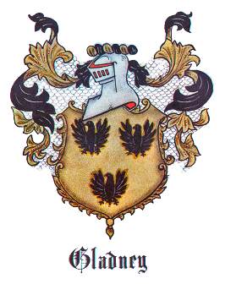 | Gladney Photos  Click on photo to enlarged.
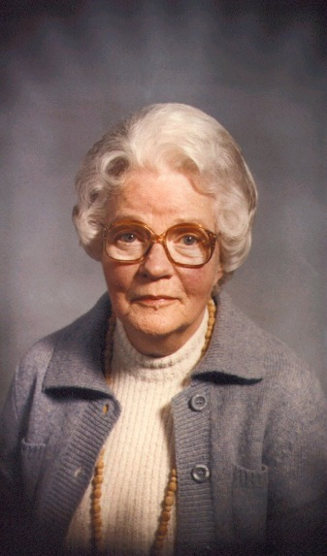 | ARNOLD, Mildred Lee Gladney - This beloved Gladney descendant, born 7 Sep 1897 at Marion AR, daughter of Dr. Richard Adair Gladney and Martha Shackelford Hodges Gladney. We are indebted to Mrs. Arnold for authoring and publishing the wonderful Gladney's In America Genealogy/Family History book in 1966. A work of family love!
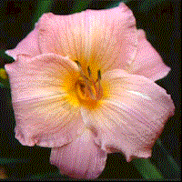 | DAYLILY, Frank Gladney -A tropical blend of coral, rose, and pink with a small gold throat. A "melt-in-your-mouth" kind of color. Big blooms on a sturdy plant. A popular variety.
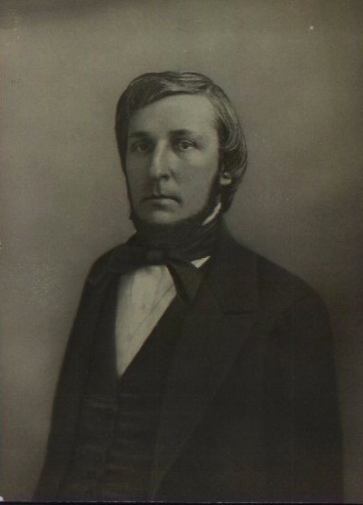 | GLADNEY, Richard Strong - Born 1806. Son of Joseph Gladney and Martha Becket Gladney. This is Mildred Lee Gladney Arnold's grandfather.
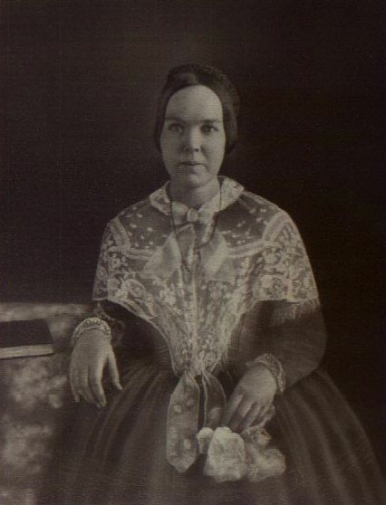 | GLADNEY, Jane Amanda McMillan - Born: 12 Mar 1812. Daughter of William A. McMillan and Anne Becket McMillan. This is Mildred Lee Gladney Arnold's grandmother.
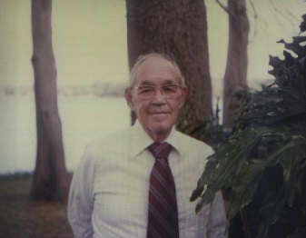 | GLADNEY, Thomas Livingston - Born: 16 Oct 1903. Picture taken 15 Mar 1978. Husband of Elsie Opal Novey Gladney. Son of Edward Chalmers Gladney and Leila Elizabeth Livingston Gladney.
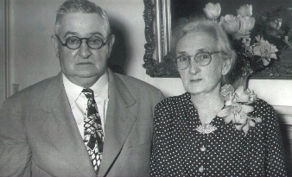 | GLADNEY, Mr. & Mrs. Wallace Gardner - Golden Wedding Anniversary, 14 Apr 1947.
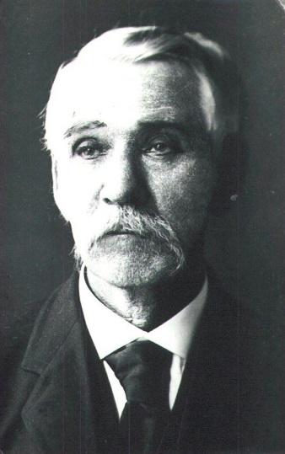 | GLADNEY, James Beckett - Born: 6 Apr 1838-Served as a Confederate soldier, later practices law, and was an outstanding educator in Chickasaw County MS. Served with Company “I” of the 11th Mississippi (Van Dorn Reserves) Infantry. Wounded. Son of Richard Strong and Jane Amanda McMillan Gladney
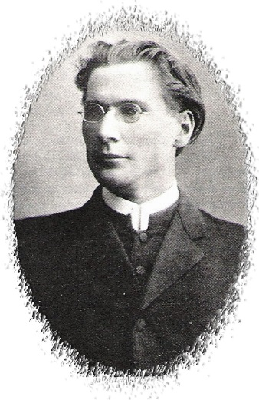 | GLADNEY, Lucien L. – Born: 26 Nov 1871. Son of John Richard Gladney and Margaret A. Bean Gladney. At the age of 91 was living in Los Angeles, keen in mind and memory, surrounded by roomful of philosophical texts, some of which he had read more than 20 times! His career included college presidency, preaching, and teaching. He was a native of Mississippi, descendant to the first Richard.
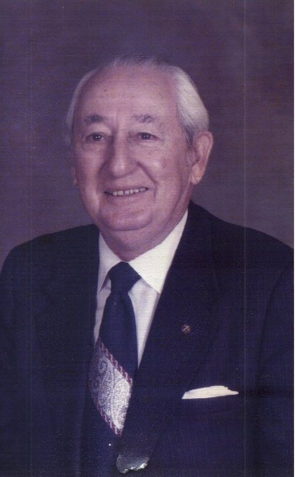 | GLADNEY, William Beckett – Born 30 Jan 1898. Husband of Ruth Anita Washburn Gladney and father of William Washburn Gladney and Charles Wallace Gladney.
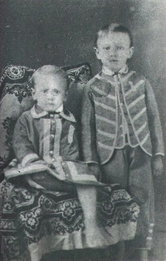 | GLADNEY, William Lamar and Wallace Gardner - William b: 25 Dec 1872, Wallace b: 18 Apr 1874. The two sons of James Beckett Gladney and Ann Alexander Barton. This picture was taken in 1879.
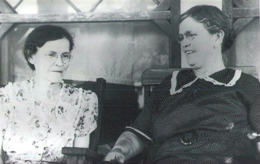 | GLADNEY, Zilda Eugenia and Elizabeth Margaret Gladney Foley - Two daughters of James Beckett and Sarah Jane Farr Gladney.
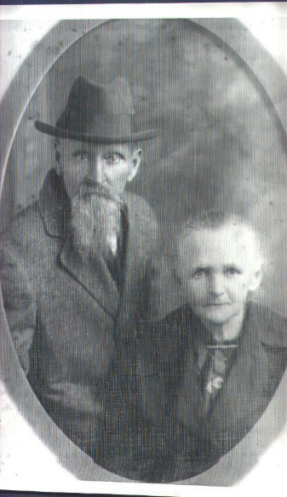 | GLADNEY, William Noah and Elizabeth Sudduth - Born: 12 Apr 1846. Husband of Elizabeth Sudduth Gladney. Parents of 10 children; Callie Ussery, Emma Alice Gladney, Robert Duke Gladney, John Fred Gladney, Annie Maude Gladney, Stella M. Gladney, Cora Lee Gladney, Mollie Gladney, Grover Stephenson, and Tommie Duke Gladney.
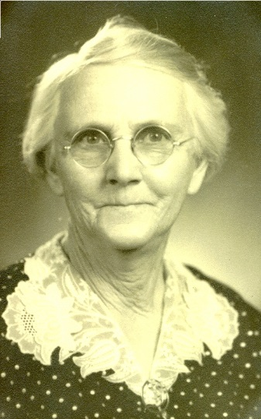 | ARNETT, Emma Alice Gladney - Born: 12 Nov 1872. Wife of Elbert Cephus Arnett. Daughter of William Noah Gladney, and Elizabeth Sudduth Gladney. Mother of Thomas Leland Arnett, William Juel Arnett, Clara Elizabeth Arnett, John Roy Arnett, Elbert Cedphus Arnett, Jr., and Raymond Morgan Arnett.
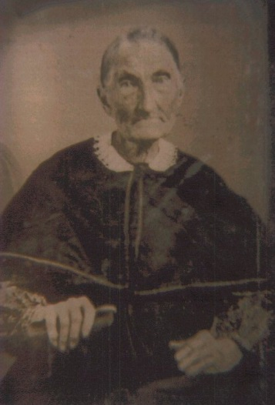 | BLACK, Agnes Nancy Gladney – Born: 30 Sep 1809. Wife of Thomas A. Black. Daughter of Richard Gladney and Mary Martha Bruce Gladney. Mother of Mary E. Black and Sarah Jane Black.
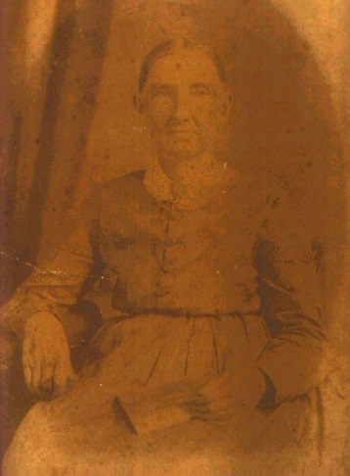 | REAP, Rachel Elizabeth Gladney – Born: 17 Feb 1818. Wife of Jonas Reap. Daughter of Richard Gladney and Mary Martha Bruce Gladney. Mother of William Jonas Reap, Samuel H. Reap, Edward C. Reap, John Reap, Mary B. Raep, John McKeowen Reap, David K. Reap, Nancy J. Reap, Charles S. Reap, and James Presley B. Reap.
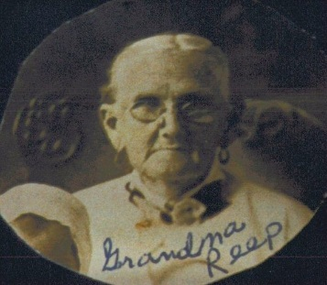 | REEP, Nancy Jane Gladney – Born: 29 May 1837. Wife of John McKeown Reap. Daughter of Edward Bruce Gladney and Elizabeth P. Hamilton. Mother of Edward J. Reap, Elizabeth Reap, Arch James Reap, David Garland Reap, Mary J. Reap, and Allie Willie Reap. Nancy Jane married her 1st cousin John McKeown Reap, son of Rachel Gladney Reap.
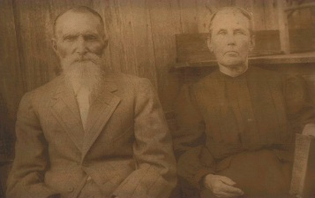 | REEP, William Jonas – Born: 1 Oct 1838. Husband of Mary Reep and Martha Emerson Gladney Reep. Son of Jonas Reep and Rachel Gladney Reep. Father of Samuel Reep, Charles J. Reep, Mary J. Reep, John Buck Reep, Elbert Weston Reep, Oscar Monroe Reep, Alice (Allie) Reep, and W. H. Reep. Photo of William and Martha.
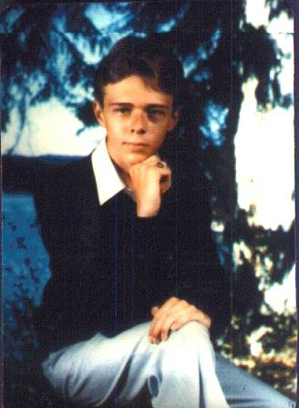 | GLADNEY, Craig Wilkins – Born: 6 Oct 1965. Husband of Anna Roe Cranor Gladney. Son of William Craig Gladney and Retta Mae Wilkins Gladney.
 | CHESNUT, John David – Born: 11 December 1938. Husband of Camma Linda Crowe Chesnut. Son of John Harvey Chesnut and Mary Rebecca Smith Chesnut. Father of Caroline Rebecca Chesnut. Holding granddaughter, Nancy Elizabeth Leslie.
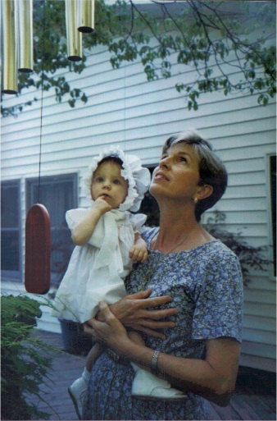 | CHESNUT, Camma Linda Crowe – Born: 3 May 1942. Wife of John David Chesnut. Daughter of Sam Hershel Crowe and Caroline Lois Perry Crowe. Holding granddaughter, Nancy Elizabeth Leslie.
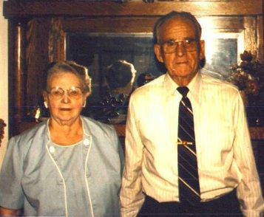 | DRIVER, Calvin Berry – Born: 15 Apr 1903. Husband of Ina Watson Driver. Son of Douglas Franklin Driver and Sevilla Ocdy Gladney. Photo of Calvin and Ina taken Jul 1985.
 | DAYLILLY, Frank Gladney – A tropical blend of coral, rose, and pink with a small gold throat. A "melt-in-your-mouth" kind of color. Big blooms on a sturdy plant. A popular variety.
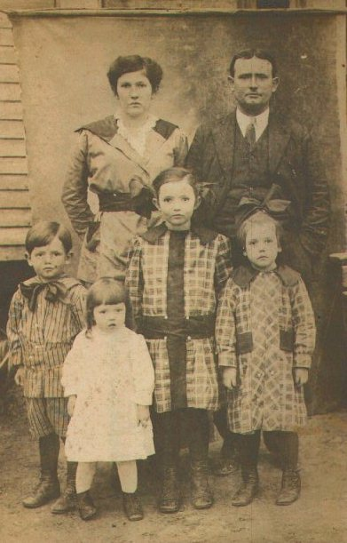 | GIBSON, Caddie Kathleen – Born: 2 Aug 1889. Wife of Carl Genus Gibson. Daughter of Samuel Bruce Gibson and Asa Breathwaite. Mother of Mildred Virginia Gibson, John Will Gibson, Lucy Tolliver Gibson, Thomas Ralph Gison, Samuel Fletcher Gibson, Mary Kathleen Gibson, and Naomi Christeen Gibson. Photo showing Carl G. Gibson, Caddie Kathleen Gibson Gibson, J. W. Gibson, Lucy Gibson Halligan, Vivian Asa Gibson Dickey, and Mildred Virginia Gibson Hogue.
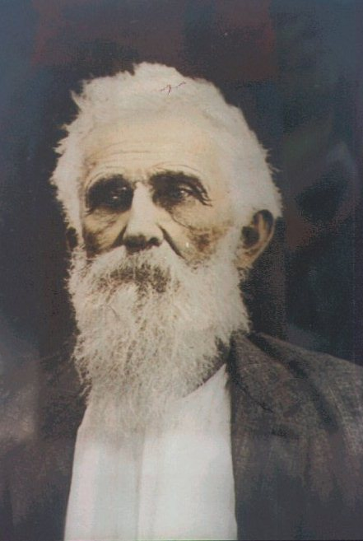 | GIBSON, Samuel Bruce – Born: 14 Nov 1841. Husband of Asa Breathwaite Gibson. Son of Silas Gibson and Jane Gladney Gibson. Father of Mary Breathwaite Gibson, Caddie Kathleen, Gibson, Willie Pebble Gibson, and Pat Cleburne Gibson.
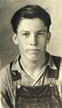 | GLADNEY, Horace W. – Born 15 Feb 1918. Wife of Louise Gladney. Son of Marvin Taylor Gladney and Carrie Brown Treadwell Gladney. Father of Wynette Gladney, Gary Gladney, Anita Gladney, and Terri Gladney.
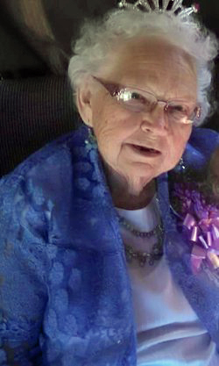 | GLADNEY, Lucille Marie Graham – Born: 17 Jan 1920. Wife of John Harvey Gladney II. Daughter of Milton Lindsey Graham and Paulene A. Nipper. Mother of Gail Gladney, Julia “Judy” Marie Gladney, and John Harvey Gladney III. Beloved GIA Member/Director.
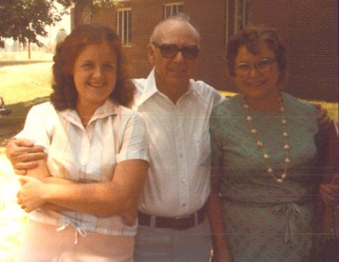 | GLADNEY, Pamela – Born: 24 Jan 1958. Daughter of Everett Berry Gladney and Lula Frank Carr Gladney. Photo of Pamela, her father Evderett and Mary Maudine Mitchell Carney at the 1976 Gladney Reunion in Winnsboro SC.
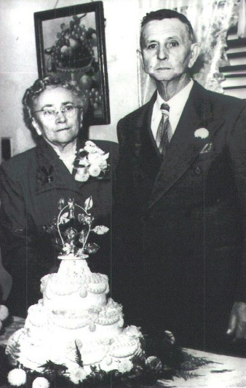 | GLADNEY, Robert Duke and Johnny Elizabeth Arnett - Born: 23 Feb 1883 and wife - born: 1881 - Golden Wedding Anniversary, 1953.
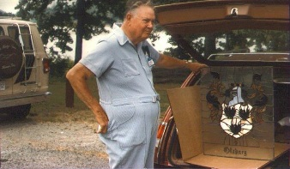 | GLADNEY, Samuiel Langhorne IV - Born: 18 Feb 1914. Served in World War II; named on bronze tablets in Bell Tower at Valley Forge PN, honoring descendants of Revolutionary soldiers who fought in World War II. Displaying his stained-glass Gladney Coat of Arms during GIA reunion at Sardis MS-15-17 Jun 1984.
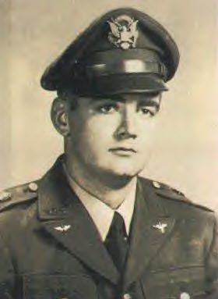 | GLADNEY, Samuel Langhorne V - Born: 26 Jun 1937. Samuel is the son of Samuel Langhorne Gladney IV and Jessie Selma Polk Gladney. Served US Army.
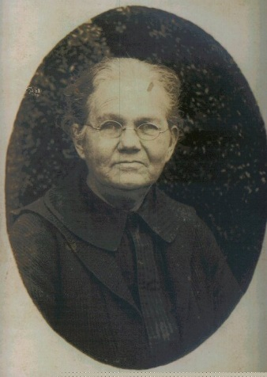 | GLADNEY, Sarah Ann Weathers – Born 27 Jul 1852. Wife of James Robert Gladney. Daughter of Isham Thomas Weathers and Sarah Ann Thompson Weathers. Mother of Lizzie Ella Gladney, Florence Isabelle Gladney, William Augustus Gladney, Thomas Ellis Gladney, Sarah Effie Jane Gladney, James Arthur Gladney, Nora Lee Gladney, Cora Lee Gladney, Ruth Willie Gladney, Gladys Valera Gladney, and Ruby Pearl Gladney.
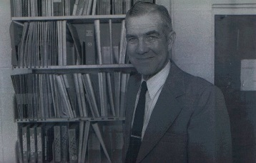 | REED, Walter McDavid – Born: 14 Dec 1925. Husband of Emma Eugene DeBose. Son of Carl Christopher Reed and Ruby Pearl Gladney Reed. Father of David Carl Reed, Daniel Thomas Reed, Rebecca Ruth Reed, and Judy Carol Reed.
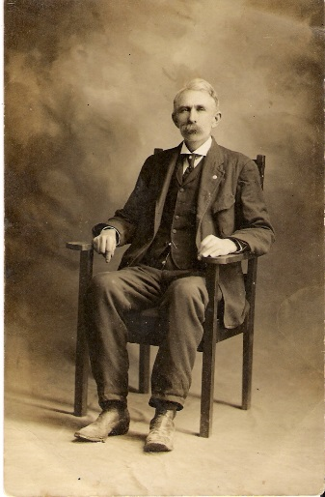 | GLADNEY, Richard Jackson - Born: Jul 1850. Husband of Leanna Assineta Nelson. Richard is the son of William McMilling Gladney and Mary Munnell Birnie Gladney. Father of William Alexander Gladney, Samuel Jackson Gladney, and Neal Clyde Gladney.
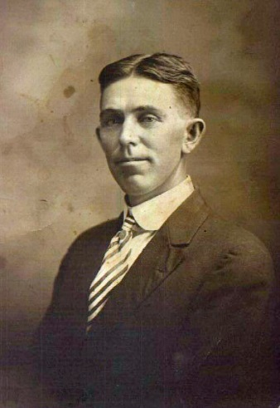 | GLADNEY, Neal Clyde - Born: 19 May 1885. Husband of Alcie Oney Henry Gladney. Neal is the son of Richard J. Gladney and Leannah Assisneta Nelson Gladney. Father of Leannah Louise Gladney Potter, Wilbur Erskin Gladney, Ruby Ethel Gladney Johnson, Dorothy O’Neal Gladney Hampton, and Sara Catherine Gladney Marbry.
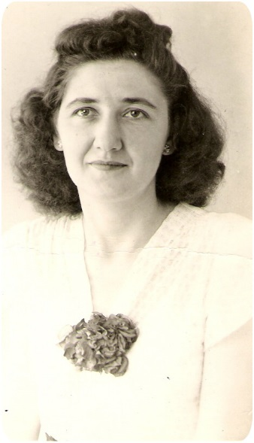 | POTTER, Leannah Louise Gladney - born: 13 Dec 1919. Wife of Halbert Brewer Potter. Leannah is the daughter of Neal Clyde Gladney and Alcie Oney Henry Gladney. Mother of Marilyn Cleo Potter, Elsie Mae Potter, Margaret Jeannette Potter, and Terry Neal Potter.
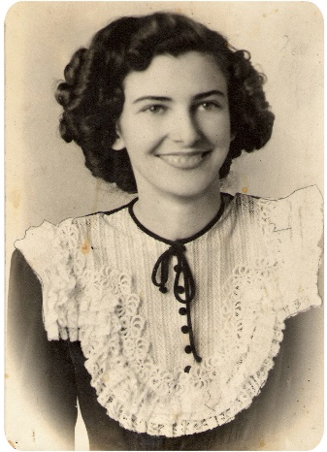 | JOHNSON, Ruby Ethel Gladney - Born: 1 Aug 1925. Wife of Harold Ross Johnson. Ruby is the daughter of Neal Clyde Gladney and Alcie Oney Henry Gladney. Mother of Mickey Don Johnson, Clyde Henry Johnson, Bonnie Jean Johnson, Willard Eric Johnson, Pamela Ruth Johnson, Timothy Ross Johnson, Glen Norman Johnson, Kenneth Alvin Johnson, and Victor Lloyd Johnson.
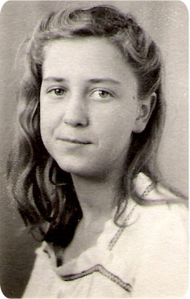 | HAMPTON, Dorothy O’Neal Gladney – Born: 17 Jan 1933. Wife of Leo Hampton. Dorothy is the daughter of Neal Clyde Gladney and Alcie Oney Henry Gladney. Mother of Brenda Mae Hampton, Dorothy Jean Hampton, Leo Duane Hampton, Michael Jeffrey Hampton, Donna Lynn Hampton, and Anthony Scott Hampton.
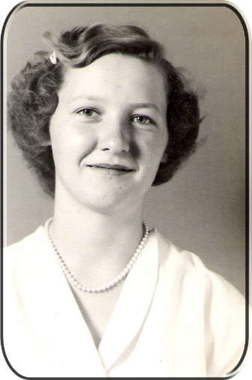 | MARBRY, Sara Catherine Gladney -Born: 7 Jun 1938. Wife of William C. Marbry. Sara is the daughter of Neal Clyde Gladney and Alcie Oney Henry Gladney. Mother of Douglas Clarence Marbry, Debra Charlene Marbry, Neal Mansfield Marbry, Mary Katherine Marbry, William Lewis Marbry, and James Leon Marbry.
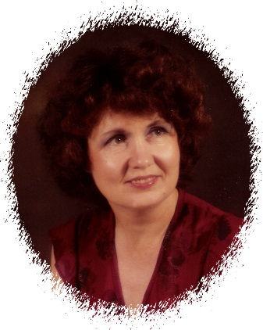 | JONES, Marilyn Cleo Potter – Born: 22 June 1939. Wife of Bobby Jones. Marilyn is the daughter of Halbert Brewer Potter and Leannah Louise Gladney Potter. Mother of Mark Wade Flake.
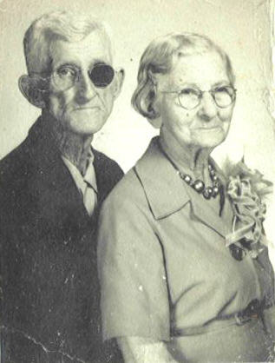 | Gladney, Samuel Calvin – Born: 20 Oct 1878. Husband of Louvella Jones Gladney. Son of Calvin Berry Gladney and Martha Borders Gladney. Father of Mary Alice Gladney, Geneva Mae Gladney, Gladys Ezel Gladney, and Cecil Ernest Gladney. Photo of Samuel and Louvella.
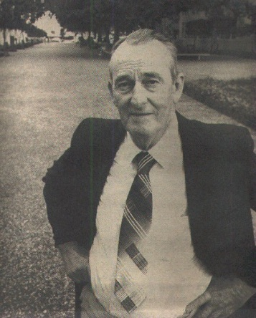 | LEE, Davis Russell – Born: 16 Nov 1920. Husband of Lillian Elizabeth Jobe Lee. Son of Clarence Adrian Lee and Mattie Gerturde Dudley Lee. Father of Glenna Lou Lee, Ronnie Russell Lee, and Debra Elizabeth Lee. Photo: Honoree, who is retiring after 47 years at Kilgore College, will have the mall area between the library and the fine arts building named in his honor following action taken by KC trustees. Stands in mall area named for him.
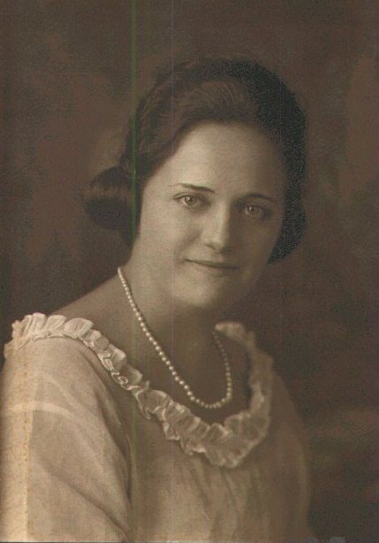 | MEADOWS, Benetta Inez Dudley – Born 7 Jun 1901. Wife of Virginia Dare Meadows. She is the daughter of John Carroll Dudley and Mary Catherine Russell. Mother of Mary Virginia Meadows, John Dudley Meadows, Delores Meadows, Lucrettia Meadows, Wayne Nathaniel Meadows, Shirley Jean Meadows, and Glenn Curtis Meadows.
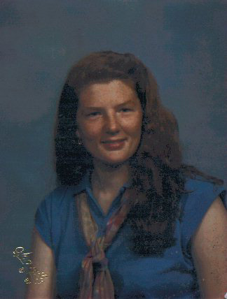 | LESLIE, Caroline Rebecca Chesnut – Born: 30 Sep 1964. Wife of Jay Wallace Leslie, Jr. Daughter of John David Chesnut and Camma Linda Crowe Chesnut. Mother of Nancy Elizabeth Leslie.
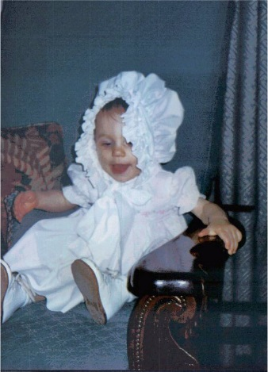 | LESLIE, Nancy Elizabeth – Born: 28 May 1996. Daughter of Jay Wallace Leslie, Jr. and Caroline Rebecca Chesnut Leslie.
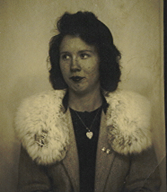 | REESE, Wilma Sue Gladney – Born: 18 Dec 1924. Wife of James H. Reese. Daughter of Marvin Taylor Gladney and Carrie Braown Treadwell Gladney. Mother of Elbert Reese, James William Reese, Joan Marie Reese, Barry Reese, and Tony Reese.
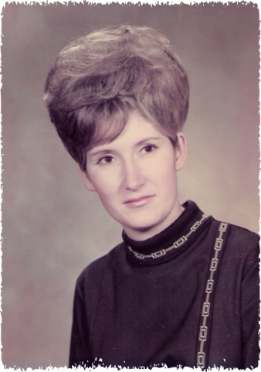 | SHERRILL, Margaret Jeannette Potter - Born: 28 Jun 1942. Wife of Kenneth Guy Sherrill. Daughter of Halbert Brewer Potter and Leannah Louise Gladney Potter. Mother of Sandra Louuise Sherrill, Sharon Gail Sherrill, and Kimberly Guy Sherrill.
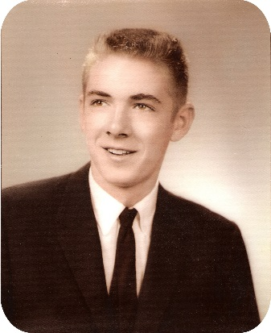 | JOHNSON, Mickey Don – Born: 14 Sep 1946. Husband of Lana Kay Tapley Johnson. Son of Harold Ross Johnson and Ruby Ethel Gladney Johnson. Father of Kelly Dawn Johnson and Emily Ann Johnson.
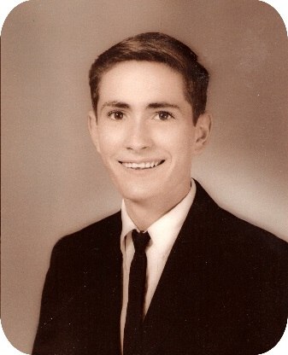 | JOHNSON, Clyde Henry – Born: 30 Jan 1948. Husband of Linda Jo Capers Johnson. Son of Harold Ross Johnson and Ruby Ethel Gladney Johnson. Father of Clyde David Johnson, Amy Elizabeth Johnson, and Ashley Nicole Johnson.
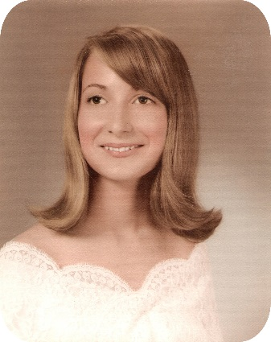 | SHIPLEY, Bonnie Jean Johnson – Born: 27 Jul 1949. Wife of Gary Lee Shipley. Daughter of Harold Ross Johnson and Ruby Ethel Gladney Johnson.
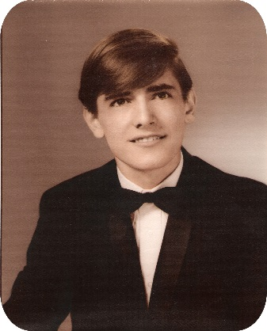 | JOHNSON, Willard Eric – Born: 12 Dec 1950. Husband of Linda Sue Williams Johnson. Son of Harold Ross Johnson and Ruby Ethel Gladney Johnson. Father of William Eric Johnson, Bart Wayne Johnson, and Jessicda Lafaye Johnson.
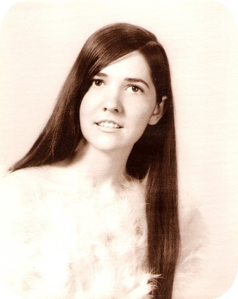 | EDWARDS, Pamela Ruth Johnson – Born: 18 Mar 1953. Daughter of Harold Ross Johnson and Ruby Ethel Gladney Johnson. Mother of Stacy Renee Edwards and Bryan Keith Edwards.
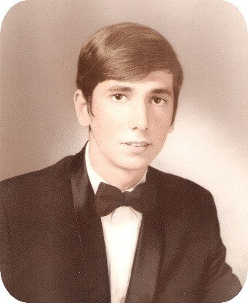 | JOHNSON, Timothy Ross – Born: 5 Nov 1954. Husband of Jill Victoria Tucker Johnson. Son of Harold Ross Johnson and Ruby Ethel Gladney Johnson. Father of Timothy Ralph Johnson, Tracy Nicole Johnson, and Trent Andrew Johnson.
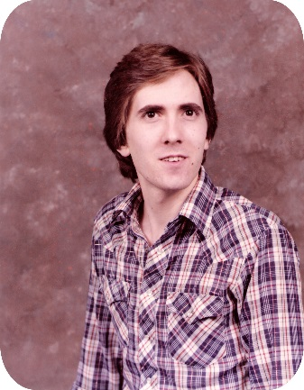 | JOHNSON, Glen Norman – Born: 30 Oct 1956. Son of Harold Ross Johnson and Ruby Ethel Gladney Johnson.
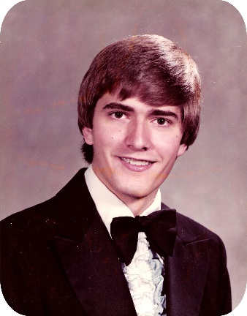 | JOHNSON, Kenneth Alvin – Born: 3 May 1961. Husband of Alice Elizabeth Sit. Son of Harold Ross Johnson and Ruby Ethel Gladney Johnson. Father of Matthew Thomas Johnson, Joshua Ross Johnson, and Andrew Christian Johnson.
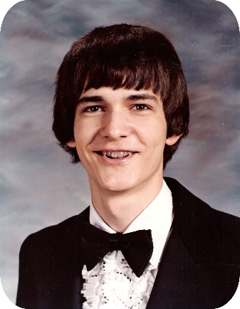 | JOHNSON, Victor Lloyd – Born: 29 Apr 1964. Husband of LaVerne Jenkins Johnson. Son of Harold Ross Johnson and Ruby Ethel Gladney Johnson.
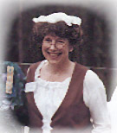 | BOND, Bettye Gene Hogue – Born: 23 July 1931. Wife of Gene Thomas Bond. Daughter of Willie C. Hogue and Mildred Virginia Gibson Hogue. Mother of Rodney Gene Bond, Michael Thomas Bond, and David Trent Bond.
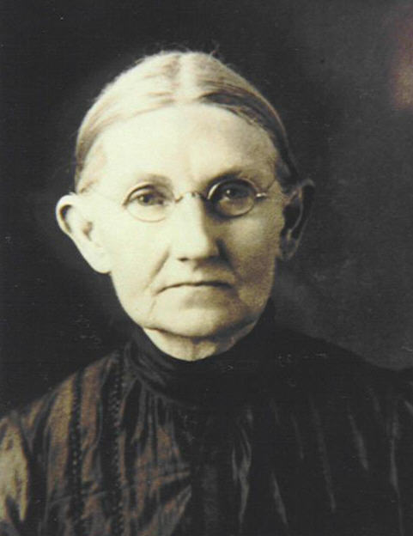 | MILLER, Mary E. Black – Born: 19 April 1844. Wife of William T. Miller. Daughter of Thomas A. Black and Agnes Nancy Gladney Black. Mother of Aguse Nancy J. Miller.
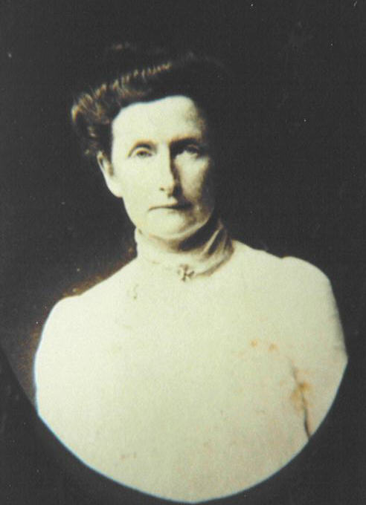 | HILLIARD, Agusse Nancy J. Miller – Born: 7 Oct 1966. Wife of Richard Clark Woodward Hilliard. Daughter of William T. Miller and Mary E. Black Miller. Mother of Lettie Loraine Hilliard, Luna May Hilliard, and Reed Clark Hilliard.
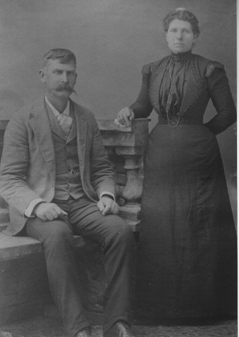 | KERR, David and Sarah Catherine Harden – Born: 14 Feb 1851. Husband of Sarah Catherine Harden Kerr. Son of Charles and Nancy Matilda Gladney Kerr. Father of Emmett James Kerr, Wilbur Young Kerr, Mollie Belle Kerr, William Pearl Kerr, Homer Weir Kerr, Everett Gladney Kerr, Annie Matilda Kerr, Charles Leland Kerr, Elizabeth Jane Kerr, Mattie Luvernia Kerr, and Margaret Gertrude Kerr.
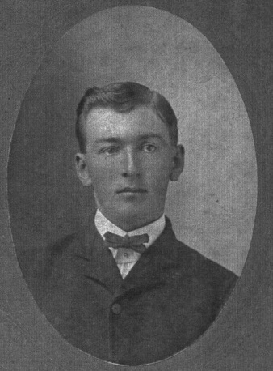 | KERR, Emmett James – Born: 13 June 1882. Husband of Maggie L. McCain Kerr. Son of David Kerr and Sarah Catherine Harden Kerr. Father of Wayne Kerr and Fairy Lee Kerr. Emmett moved to Crowley LA when he was a young man, married Maggie and became a successful rice farmer. He was reportedly 17 years old when this picture was made.
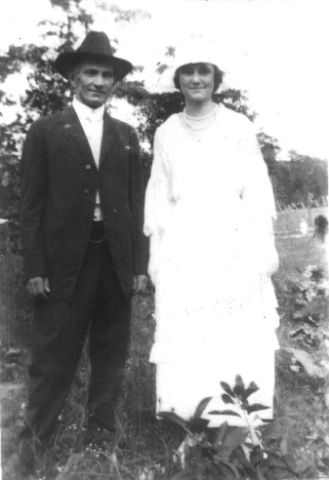 | KERR, Everett “Eb” and Alice Priscilla Gordon – On their wedding day in 1919.
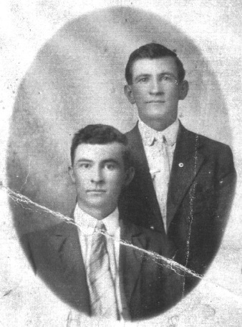 | KERR, Everett “Eb” - The man who is seated is Forest (or Forrest) Howard Bowie. The two men in the picture married sisters. Eb married Priscilla Gordon, and Howard married Laura Elizabeth Gordon.
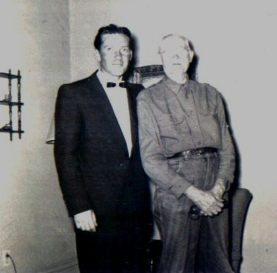 | GLADNEY, Junius Eustice – Born 5 March 1877. Husband of Jane Genevieve Zellner. Son of Samuel Lynchfield Gladney and Elizabeth Grace Burks Gladney. Father of Samuel Langhorne Gladney IV and John William Gladney. With his son, John William Gladney.
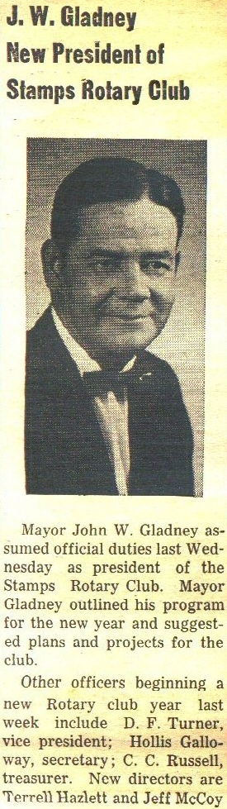 | GLADNEY, John William – Born 5 Apr 1918. Husband of Pauline Alsobrooks Gladney. Son of Junius Eustice Gladney and Jane Genevieve Zellner Gladney and later Helen Jean Henry Gladney. Served in World War II; named on bronze tablets in Bell Tower at Valley Forge PN, honoring descendants of Revolutionary soldiers who fought in World War II. Mr. Gladney was member and elder in the Stamps Presbyterian Church, member of the Masonic Lodge for 50 years, member of the American Legion, member of the DAV, VFW, and Forty & Eight Veterans Organization. Mr. Gladney was past Commander and District Commander of the American Legion and was a former Mayor of Stamps.
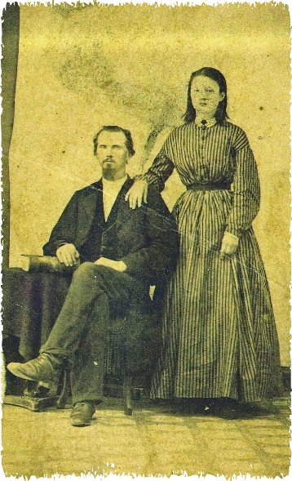 | GLADNEY, John A. and Catherine Davis - John b: 6 Jun 1836. Catherine b: 25 Dec 1852. Parents of Lillie Cooper Gladney, Walter Alcorn Gladney, Manley Gladney, Jessie Gladney, and Ora Lee Gladney.
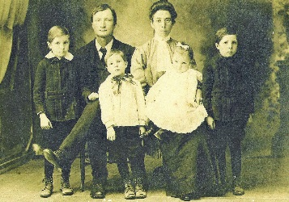 | GLADNEY, Walter Alcorn - Born: 23 Dec 1878. Husband of Maggie Viola Smith Gladney b: 2 Jun 1879. Parents of (left to right) Jewel Sylvain Gladney b: 1902, Johnie Gladney b: 1 Nov 1906, Daisy Viola Gladney b: 3 Nov 1909, Jessie Paul Gladney b: 17 Nov 1904.

